FASTSIGNS, Inc.

Send A File / Request A Quote

Process Diagram

This document serves to outline the logical progression of users through the Request A Quote (RAQ) and Send A File (SAF) components of the website. At the time of this writing, both systems are identical and use the same code-base.

Step 1: Is the user logged-in?
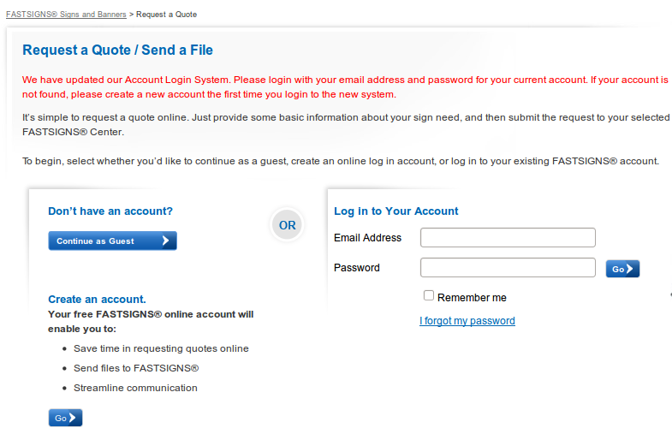
Yes: Go directly to step 2. This screen is not displayed to users who are already logged-in.
No: Prompt the user with the above screen and give them a choice:
        - Do they have an account and want to log in?
        - Would they like to create a login account as part of this submission?
        - Would they like to proceed as a guest. (login not required, create-account not required)

Step 2: Locate a Center
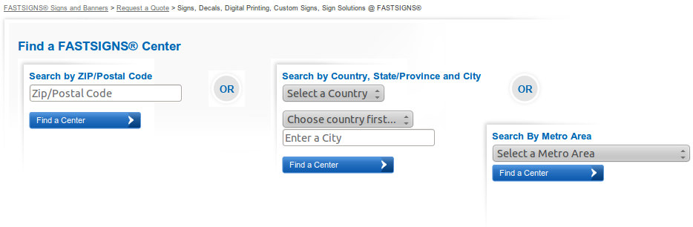
Once we identify if the user is logged-in, will proceed as a guest, or wants create an account along the way, we need to identify which FASTSIGNS Center they desire to work with. This is done one of two ways:
    - If the user was already on a Center's page when they clicked into the RAQ/SAF system, that Center's WebID (a unique value) was passed as part of the request. For these cases we already know which Center the user desires to work with, therefore this screen is skipped.
    - If we do not know which Center the user wants to work with, the Locator form (above) is presented. This allows to user to find a center near their address/location to work with. The users makes a selection prior to continuing to step 3.

Step 3: Complete the Information Request Form
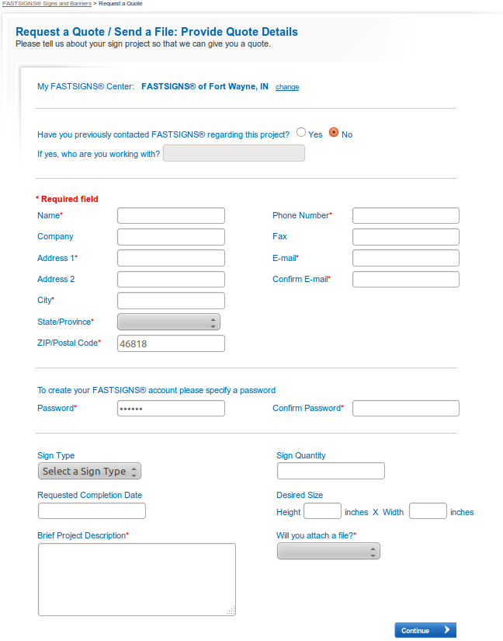

The information request form captures the user's contact information and the nature of their request. For logged-in users, the personal information fields (on the form) are automatically populated.
At the top of the form, the Center they chose to work with is displayed. (FASTSIGNS of Fort Wayne, IN, in this example)
The section containing the password fields (in the middle) is only presented to non-logged-in users who specified they wanted to create a new account in step 1. The only difference between creating an account and continuing as a guest (in Step 1) is the presentation of the Password and Confirm Password fields.
The bottom section asks questions specific to the nature of the request. Depending on how the user answers the question “Will you attach a file?” determines what happens next. If they choose “Yes – sending it now” they proceed to step 4. All other options skip step 4, going directly to step 5.

Step 4: Prompt the User to Upload Their File(s)
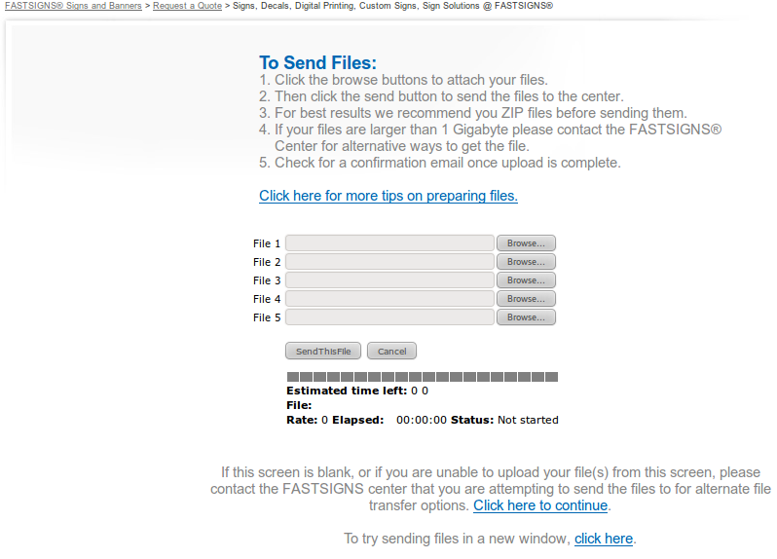
On this screen the user is asked to upload the file or files they wish to provide to the FASTSIGNS Center. They can upload a maximum of five files. Upon submission, the files are uploaded directly to sendthisfile.com (not the fastsigns.com website). A progress meter encourages the user to be patient while their files (sometimes quite large) are uploaded. SendThisFile.com provides us behind-the-scenes confirmation that the files were received successfully, as well as URLs to retrieve those files (used later). Once we receive that confirmation the user progressed to Step 5.

Step 5: Quote Received / Confirmation
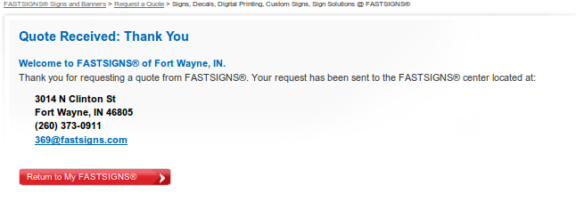
The final screen informs the user that their submission was successful and is now complete. The Center's information is again displayed should they desire to communicate directly with the Center (to follow-up). At this step, the RAQ/SAF process is complete.

Post-Processing
Once the RAQ/SAF submission is complete, an email containing the submitted information is sent to the specified Center (directly). A nearly-identical email is also sent to the user, as confirmation of their submission.

Sample Email Sent to the User
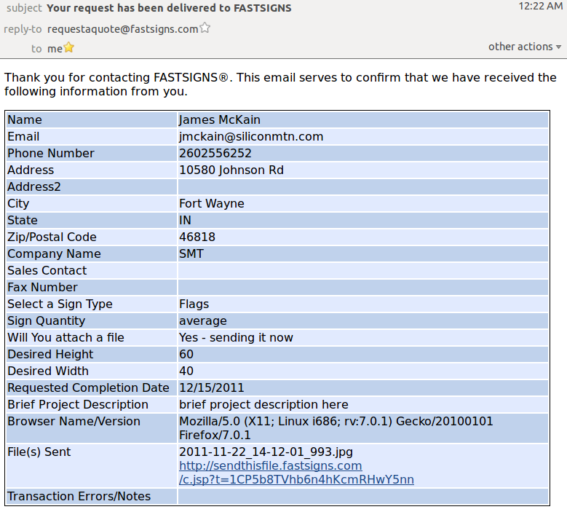

Sample Email Sent to the Center
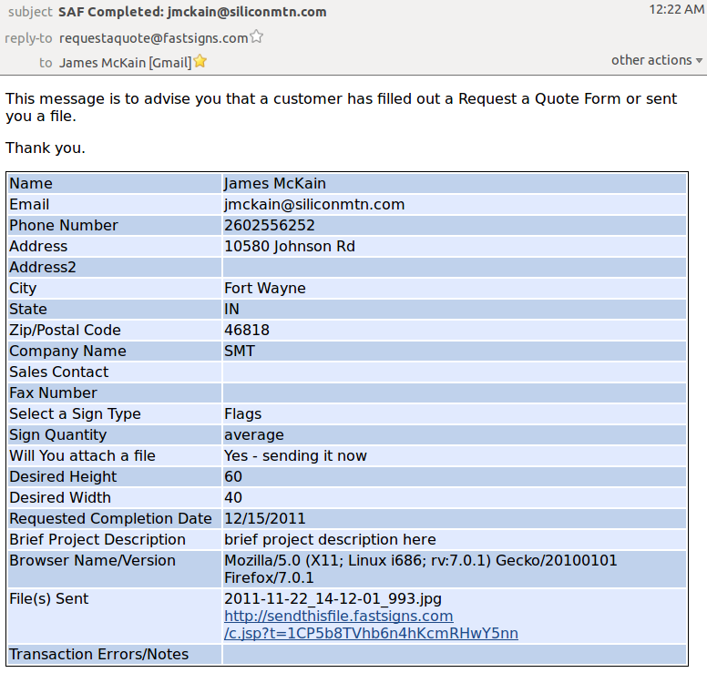

Accommodating Errors and Anomalies
In some cases a user will indicate they are uploading a file and then choose to abort their submission (and not upload a file). Other times a user will attempt to upload a file that is too large, or is taking too long, and again choose to abort the process. Some users have reported that large uploads cause their browser to freeze, or that file upload is being blocked by their firewall (personal or corporate). Whatever the reason, a back-end process runs every two hours to scan the system for aborted submissions. This process attempts to evaluate whether a file was indeed uploaded (by contacting SendThisFile.com), and what error caused abortion of the process. The process then automatically completes these submissions for the user, which triggers the emails (above) to be sent to both the Center and the user. For these cases, there is a field in the emails called “Transaction Errors/Notes”, which gets populated with the probable-cause of the complication encountered by the user.

WebEdit - Reporting Interface
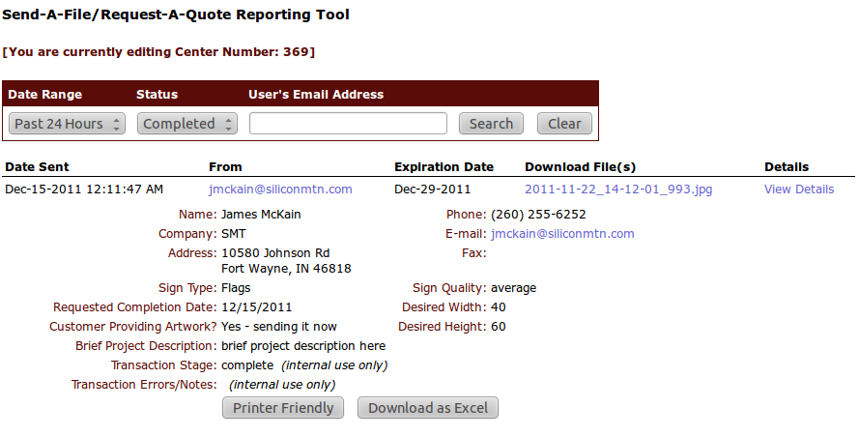
The WebEdit tool has a component called “SAF Report”, which is filtered for each Center (to display their submissions only). Here the Center admins and eTeam can query the system to see recently-submitted RAQ/SAF requests, and examine the transaction/data. This is the same information provided in the automated emails. Admins can also choose to export the data to Excel or to a printable format. End-users cannot access this tool.

